Poverty Bay Agricultural & Pastoral Association
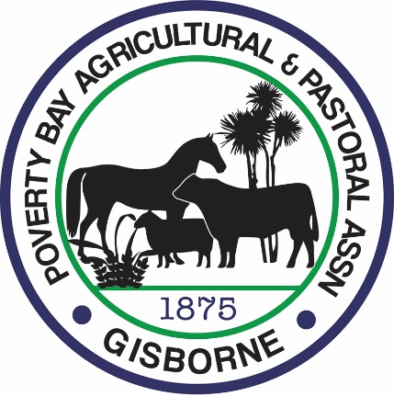
SCHOLARSHIP
The Poverty Bay A&P Association invites you to apply for the
Poverty Bay A&P Scholarship.
The Scholarship aims to assist a student enrolled in a fulltime programme related to the primary industries, at a New Zealand University or Tertiary Institute in New Zealand
The Poverty Bay A&P Scholarship recipient will receive.
$2000.00 (incl. GST) payable towards their course costs/accommodation.

The recipient will be from the Gisborne or East Coast region and wish to be involved in the primary based industry. (e.g. Agriculture, Horticulture, Forestry, Fishing)
The criteria for selection will be based on leadership potential, academic merit and commitment to the industry.
It is hoped the scholarship recipient will ultimately seek employment in Poverty Bay and pass on the benefits of their learning to the Poverty Bay community and its industries.
The scholarship will be awarded by a Selection Panel of members comprising:
- A representative from the Poverty Bay A&P Association
- A recognised person from the primary industries community

An application form is enclosed. Additional copies are available from the A&P Office at Showgrounds Park or through our website – www.gisborneshow.co.nz
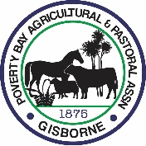
APPLICATION FOR
POVERTY BAY A&P ASSN. SCHOLARSHIP
Please complete the following details and attach the required documentation with your application. All applications must be received by the Poverty Bay A&P Association by
26th November 2021
Post to Poverty Bay A&P Assn. P O Box 2186, Gisborne 4040
Email to: info@gisborneshow.co.nz
All sections must be completed
Full Name ………………………………………………………………………………………
Address ……………………………………………………………………………………….
Email ………………………………………………………………………………………
Phone ………………………………………….. Date of Birth ……………………….

Tertiary Institute enrolled at ………………………………………………………………
Programme of Study ………………………………………………………………
Length of Course ……………………………………………………………...

Secondary School attended ………………………………………………………………
From year …….. To year ……… Highest Qualification …………………………………….

Academic Achievements: (Please list any relevant academic achievements and applicable dates)
……………………………………………………………………………………………………..
…………………………………………………………………………………………………….
……………………………………………………………………………………………………..
Work Experience: (Please list any relevant work experience and applicable dates)
…………………………………………………………………………………………………….
…………………………………………………………………………………………………….
……………………………………………………………………………………………………

CONDITIONS

The course of study must be fulltime for at least one year

This application form must be accompanied by the following
- Proof of enrolment at a University or Tertiary Institute for a minimum of a one-year fulltime course

- A copy of any academic qualifications

- A reference from your school

- A reference from any previous employer if relevant

Please write an application essay covering the following two sections and submit in a typed document with your application
- What inspired you to undertake your course of choice and what contribution do you hope to make to the Primary industries and Poverty Bay

- What challenges and opportunities do you see for the Primary Industries in Poverty Bay

Selection Process and Key Dates:
29th November 2021 - Applications close
December 2021 - Applications reviewed
January 2022 - The successful recipient will be announced.
The scholarship will be paid via DC to nominated bank account to the successful recipient in one instalment in the first semester of study around the 1st February 2022.

I have read the criteria for the Poverty Bay A & P Scholarship and I agree to the terms and conditions and confirm that all the details are correct.

I accept that the material included with this application will remain the property of the Poverty Bay A & P Association and may be used in the promotion of this Scholarship according to the principles of the Privacy Act 1993.
The Selection Panel’s decision is final, and no correspondence will be entered into.

Signature …………………………………………… Date ………………………………

